Face Sign Admin Dashboard - Low Level Design

1. Executive Summary

Face Sign Admin Dashboard is an administrative interface for managing digital document signing sessions with facial recognition/KYC verification. The platform provides two distinct interfaces: a Client Dashboard for businesses using Face Sign services and an ICP Console for Face Sign internal staff to manage organizations and monitor platform health.

Core Capabilities:
- Session/Contract management and monitoring
- Organization onboarding and management (ICP)
- User and team management
- API key generation and management
- Analytics and reporting
- Billing and subscription management
Key Integrations:
- UAE KYC for identity verification
- Face Sign Backend API
- MinIO/S3 for document storage
- ClickHouse for analytics and audit logging
- Kafka for event streaming

2. Detailed Feature Specification

2.1 PLATFORM ADMINISTRATION (ICP Console)

ID | Feature | Description | Sub-Features | Deps
F1.1 | Organization Management | Onboard and manage client organizations. View all organizations, their status, and drill down into details. | • Organization listing with search/filter  • Organization detail view  • Status management (active/suspended/archived)  • Organization statistics (contracts, users, API usage)  • Quick actions (view contracts, manage users) | None
F1.2 | Client Onboarding Wizard | Multi-step wizard to onboard new client organizations with all required configuration. | • Step 1: Organization details (name, legal entity, contact)  • Step 2: Admin user creation (email, name, role)  • Step 3: API configuration (environment, rate limits)  • Form validation at each step  • Progress indicator  • Review and submit | F1.1
F1.3 | ICP Analytics Dashboard | Platform-wide analytics for internal staff to monitor health and usage. | • Total organizations count  • Total contracts across platform  • Completion rate metrics  • Contracts over time chart  • Organization-wise breakdown  • Real-time status indicators | F1.1
F1.4 | ICP Contract Monitoring | View and filter all contracts across all organizations for support and monitoring. | • Global contract listing  • Filter by organization  • Filter by status  • Filter by date range  • Contract detail drill-down  • Export capabilities | F1.1

2.2 CLIENT DASHBOARD

ID | Feature | Description | Sub-Features | Deps
F2.1 | Client Dashboard Home | Primary landing page showing key metrics and recent activity for the logged-in organization. | • Stats cards (total contracts, completed, pending, failed)  • Contracts over time chart (7/30/90 days)  • Recent contracts list  • Quick action buttons  • Status breakdown pie chart | None
F2.2 | Contract Management | Core feature for viewing, filtering, and managing signing contracts/sessions. | • Contract listing table with pagination  • Column sorting (date, status, signer)  • Status filter (all, completed, pending, failed, expired)  • Date range filter  • Search by contract ID or signer  • Bulk selection capability  • Export to CSV | F2.1
F2.3 | Contract Detail View | Detailed view of individual contract with full metadata and timeline. | • Contract metadata display  • Signer information  • Document preview  • Status timeline/history  • Signature position data  • Hash verification info  • Related actions (cancel, retry) | F2.2
F2.4 | Contract Filters | Advanced filtering system for contract search and segmentation. | • Status filter dropdown  • Date range picker (from/to)  • Signer name search  • Contract ID search  • Filter persistence in URL  • Clear all filters action | F2.2

2.3 USER MANAGEMENT

ID | Feature | Description | Sub-Features | Deps
F3.1 | Users List | Display and manage team members within an organization. | • User table with columns (name, email, role, status, last active)  • Pagination (10/20/50 per page)  • Search by name or email  • Sort by columns  • Add new user button  • Edit/delete actions per row | None
F3.2 | User Form | Create and edit user profiles with role assignment. | • Name input (required)  • Email input (required, validated)  • Role selection (Admin, Manager, Viewer)  • Status toggle (active/inactive)  • Form validation  • Submit/cancel actions | F3.1
F3.3 | User Roles | Role-based access control for dashboard features. | • Admin: Full access to all features  • Manager: Can manage contracts and view analytics  • Viewer: Read-only access to contracts  • Role displayed as badge in user list  • Role-based navigation visibility | F3.1

2.4 API KEY MANAGEMENT

ID | Feature | Description | Sub-Features | Deps
F4.1 | API Keys List | Display all API keys for the organization with status and usage info. | • Key table (prefix, name, environment, status, created, last used)  • Environment badge (Production/Sandbox)  • Status badge (Active/Revoked)  • Copy key prefix action  • Revoke key action  • Delete key action | None
F4.2 | Create API Key | Generate new API keys with environment and permission configuration. | • Key name input (required)  • Environment selection (Production/Sandbox)  • Permission scopes (future)  • Generate button  • Display full key once (security)  • Copy to clipboard  • Warning about one-time display | F4.1
F4.3 | Key Security | Security measures for API key management. | • Keys masked after creation (only prefix shown)  • Revoke functionality (soft delete)  • Last used timestamp tracking  • Environment isolation  • Confirmation dialogs for destructive actions | F4.1

2.5 ANALYTICS & REPORTING

ID | Feature | Description | Sub-Features | Deps
F5.1 | Analytics Dashboard | Comprehensive analytics view for contract performance and trends. | • KPI stat cards with trend indicators  • Time period selector (7/30/90 days)  • Contracts over time line chart  • Status breakdown donut chart  • Drop-off funnel visualization  • Refresh data action | None
F5.2 | Stats Cards | Key performance indicators displayed as cards. | • Total Contracts (count + % change)  • Completed (count + completion rate)  • Pending (current active sessions)  • Failed (count + failure rate)  • Trend arrows (up/down/neutral)  • Click to filter contracts | F5.1
F5.3 | Charts & Visualizations | Interactive charts for data visualization. | • Line chart: Contracts over time  • Donut chart: Status breakdown  • Funnel chart: Drop-off analysis  • Responsive sizing  • Tooltips on hover  • Legend with toggle | F5.1
F5.4 | Drop-off Funnel | Visualize where users abandon the signing flow. | • Stages: Created → Previewing → KYC → Positioning → Complete  • Count at each stage  • Percentage conversion between stages  • Visual funnel representation  • Identify bottlenecks | F5.1

2.6 BILLING & SUBSCRIPTION
ID | Feature | Description | Sub-Features | Deps
F6.1 | Current Plan | Display current subscription plan and usage. | • Plan name and tier  • Billing cycle (monthly/annual)  • Next billing date  • Current usage vs limits  • Upgrade plan button  • Manage subscription link | None
F6.2 | Usage Metrics | Track API and feature usage against plan limits. | • API calls used/limit  • Contracts created/limit  • Storage used/limit  • Progress bars for each metric  • Warning at 80% usage  • Overage pricing info | F6.1
F6.3 | Invoice History | View and download past invoices. | • Invoice table (date, amount, status, actions)  • Status badge (Paid/Pending/Overdue)  • Download PDF action  • View invoice details  • Pagination for history  • Filter by date/status | F6.1

2.7 SETTINGS & CONFIGURATION
ID | Feature | Description | Sub-Features | Deps
F7.1 | Organization Settings | Configure organization-level settings and preferences. | • Organization name edit  • Logo upload  • Contact information  • Timezone selection  • Default language  • Save changes action | None
F7.2 | Notification Settings | Configure alert and notification preferences. | • Email notifications toggle  • Contract completion alerts  • Failed contract alerts  • Usage limit warnings  • Weekly summary reports  • Notification channels | F7.1
F7.3 | Security Settings | Security-related configuration options. | • Two-factor authentication  • Session timeout settings  • IP whitelist management  • Password policy  • Audit log access | F7.1

3. API Specifications

3.1 Authentication APIs

Endpoint | Method | Description | Used By
/v1/auth/login | POST | Authenticate user with email/password | Login Page
/v1/auth/logout | POST | Invalidate current session | Header (Logout)
/v1/auth/refresh | POST | Refresh access token | All Pages (Auto)
/v1/auth/me | GET | Get current user profile and permissions | Layout (User Menu)
/v1/auth/password/change | POST | Change user password | Settings > Security
/v1/auth/2fa/verify | POST | Verify 2FA code | Login Page

3.2 Organization APIs (ICP Console)

Endpoint | Method | Description | Used By
/v1/admin/organizations | GET | List all organizations with pagination, search, filters | ICP > Organizations List
/v1/admin/organizations | POST | Create new organization (onboarding) | ICP > Onboard Client Wizard
/v1/admin/organizations/{id} | GET | Get organization details with stats | ICP > Organization Detail
/v1/admin/organizations/{id} | PUT | Update organization details | ICP > Organization Detail
/v1/admin/organizations/{id} | DELETE | Archive/delete organization | ICP > Organization Detail
/v1/admin/organizations/{id}/status | PATCH | Update organization status (active/suspended) | ICP > Organization Detail
/v1/admin/organizations/{id}/stats | GET | Get organization statistics | ICP > Organization Detail
/v1/admin/organizations/{id}/contracts | GET | List contracts for specific organization | ICP > Organization Detail
/v1/admin/organizations/{id}/users | GET | List users for specific organization | ICP > Organization Detail

3.3 Contract/Session APIs
Endpoint | Method | Description | Used By
/v1/contracts | GET | List contracts with pagination, filters (status, date, search) | Contracts Page, Dashboard (Recent)
/v1/contracts/{id} | GET | Get contract details with full metadata | Contract Detail Page
/v1/contracts/{id}/cancel | POST | Cancel an active contract | Contract Detail Page
/v1/contracts/{id}/timeline | GET | Get contract status history/timeline | Contract Detail Page
/v1/contracts/{id}/document | GET | Get document preview URL | Contract Detail Page
/v1/contracts/{id}/artifacts | GET | Get signature artifacts (positions, template) | Contract Detail Page
/v1/admin/contracts | GET | List ALL contracts across organizations (ICP only) | ICP > Contracts Page

3.4 User Management APIs
Endpoint | Method | Description | Used By
/v1/users | GET | List users in organization with pagination, search | Users Page
/v1/users | POST | Create new user in organization | Users Page (Add User Modal)
/v1/users/{id} | GET | Get user details | Users Page (Edit Modal)
/v1/users/{id} | PUT | Update user details (name, role, status) | Users Page (Edit Modal)
/v1/users/{id} | DELETE | Delete/deactivate user | Users Page
/v1/users/{id}/invite | POST | Resend invitation email | Users Page
/v1/users/roles | GET | Get available roles and permissions | Users Page (Role Dropdown)

3.5 API Key Management APIs
Endpoint | Method | Description | Used By
/v1/api-keys | GET | List API keys for organization | API Keys Page
/v1/api-keys | POST | Generate new API key | API Keys Page (Create Modal)
/v1/api-keys/{id} | GET | Get API key details (not the secret) | API Keys Page
/v1/api-keys/{id} | DELETE | Delete API key | API Keys Page
/v1/api-keys/{id}/revoke | POST | Revoke API key (soft delete) | API Keys Page
/v1/api-keys/{id}/rotate | POST | Rotate API key (generate new secret) | API Keys Page

3.6 Analytics APIs

Endpoint | Method | Description | Used By
/v1/analytics/summary | GET | Get KPI summary stats (total, completed, pending, failed) | Dashboard, Analytics Page
/v1/analytics/contracts-over-time | GET | Get contracts count by date for chart | Dashboard, Analytics Page
/v1/analytics/status-breakdown | GET | Get contract counts by status | Dashboard, Analytics Page
/v1/analytics/drop-off-funnel | GET | Get funnel data (stage counts) | Analytics Page
/v1/analytics/trends | GET | Get trend percentages (vs previous period) | Dashboard, Analytics Page
/v1/admin/analytics/platform | GET | Get platform-wide analytics (ICP) | ICP > Dashboard
/v1/admin/analytics/organizations | GET | Get analytics breakdown by organization | ICP > Analytics

3.7 Billing APIs
Endpoint | Method | Description | Used By
/v1/billing/usage | GET | Get current usage metrics | Billing Page, Dashboard

3.8 Settings APIs
Endpoint | Method | Description | Used By
/v1/settings/organization | GET | Get organization settings | Settings Page
/v1/settings/organization | PUT | Update organization settings | Settings Page
/v1/settings/organization/logo | POST | Upload organization logo | Settings Page
/v1/settings/notifications | GET | Get notification preferences | Settings Page
/v1/settings/notifications | PUT | Update notification preferences | Settings Page
/v1/settings/security | GET | Get security settings | Settings Page
/v1/settings/security | PUT | Update security settings | Settings Page
/v1/settings/ip-whitelist | GET | Get IP whitelist | Settings Page
/v1/settings/ip-whitelist | PUT | Update IP whitelist | Settings Page

3.9 Audit Log APIs

Endpoint | Method | Description | Used By
/v1/audit-logs | GET | List audit logs with filters | Settings > Audit Logs
/v1/audit-logs/export | GET | Export audit logs | Settings > Audit Logs
/v1/admin/audit-logs | GET | List ALL audit logs (ICP only) | ICP > Audit Logs

4. Critical Implementation Path

# | Feature ID | Feature | Gates | Required APIs
1 | AUTH | Authentication | All pages | /v1/auth/*
2 | F1.1 | Organization Management | All org-scoped features | /v1/admin/organizations/*
3 | F2.2-F2.4 | Contract Management | Core functionality | /v1/contracts/*
4 | F5.1-F5.4 | Analytics | Reporting capability | /v1/analytics/*
5 | F3.1-F3.3 | User Management | Team features | /v1/users/*
6 | F4.1-F4.3 | API Key Management | Integration setup | /v1/api-keys/*
7 | F7.1-F7.3 | Settings | Configuration | /v1/settings/*
8 | F1.2-F1.4 | ICP Console Features | Internal operations | /v1/admin/*

5. Integration Points

5.1 Upstream Integrators (External Clients)

Endpoint | Method | Description
POST /v1/sessions/init | POST | Create signing sessions with document and preset positions
GET /v1/sessions/{id}/status | GET | Poll session status and retrieve artifacts
Kafka Events (optional) | - | Consume session lifecycle events (created, completed, failed, expired)

5.2 Downstream Services

Service | Purpose | Integration Type
UAE KYC | Identity verification | API calls + webhook callbacks
MinIO/S3 | Document and template storage | S3-compatible API
ClickHouse | Audit logging and analytics data warehouse | Direct insert + query
Kafka | Event streaming to integrators | Producer for session events
PostgreSQL | Primary data storage | Direct connection

5.3 Stitching Service Integration
Integration | Description
Hash Token (JWT) | Stitching service verifies JWT signature using Face Sign's public key
Document Hash Validation | Stitching downloads document, recomputes hash, validates against JWT
Template Hash Validation | Stitching validates template image hash before overlay

5.4 Dashboard ↔ Backend Data Flow

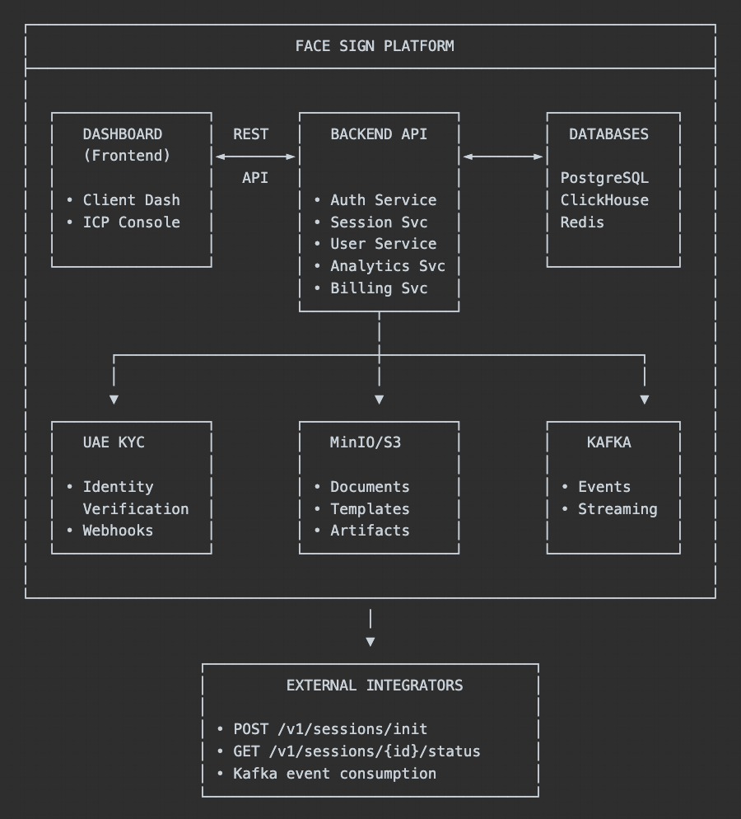

6. Security

6.1 Compliance

Standard | Description
UAE Data Protection Law | Full compliance with UAE data residency and protection requirements
ISO 27001 | Information security management certification
SOC 2 Type II | Security, availability, and confidentiality controls

7. Appendix

7.1 Glossary

Term | Definition
Contract | A signing session instance; represents one signer on one document
Session | Synonymous with Contract in this context
ICP | Internal Control Panel; admin interface for Face Sign staff
Client Dashboard | Interface for organizations using Face Sign services
Organization | A business entity that integrates Face Sign (client/integrator)
Signer | End user who signs a document through Face Sign
KYC | Know Your Customer; identity verification process
Hash Authority | Face Sign's role as single source of truth for document hashes
Artifacts | Outputs from completed session: signature positions and template
Template | Personalized signature image generated from KYC-verified identity
Preset Positions | Signature positions pre-defined by integrator

